**SIR APOLLO KAGGWA SCHOOLS**

**END OF TERM I JOINT EXAMINATION 2014**

**PRIMARY THREE**

**LITERACY II**

***Time allowed: 2 hours 15 minutes***

**Name: ______________________________________________________________**

**School: _____________________________________________________________**

**FOR EXAMINER’S USE ONLY**

**Read the following instructions carefully:**

1. The paper has **two** sections: **A** and **B**
2. Section **A** has 40 questions (40 marks)

**FOR EXAMINER’S USE ONLY**

|  |  |  |
| --- | --- | --- |
| **Qn. No** | **MARK** | **SIGN** |
| **1 – 10** |  |  |
| **11 – 20** |  |  |
| **21 – 30** |  |  |
| **31 – 40** |  |  |
| **41 – 43** |  |  |
| **44 – 46** |  |  |
| **47 – 49** |  |  |
| **50 – 52** |  |  |
| **53 – 55** |  |  |
| **TOTAL** |  |  |

1. Section **B** has 15 questions (60 marks)
2. Answer **ALL** questions. All answers to both Sections A

and B must be written in the spaces provided.

1. All answers must be written using a blue or black ball

point pen or ink. Diagrams should be drawn in pencil.

1. Unnecessary crossing of work may lead to loss of marks.
2. Any handwriting that cannot be easily read may lead to

loss of marks.

1. Do **not** fill anything in the boxes indicated; For Examiner’s

use only.

***Turn over***

**SECTION A**

**In each of the questions 1 to 5, fill in the blank space with a suitable word.**

1. A __________________ is a drawing of an object as seen from the sides.

2. __________________ was Kintu’s wife.

3. The sun rises from the __________________ direction.

4. The mother of your mother is called __________________.

5. The sick people go to __________________ for treatment.

**In each of the questions 6 to 10, complete the sentence with the suitable word from the brackets.**

6. Farmers grow cotton in order to get __________________ (**food, money**)

7. The land surrounded by water in a lake is called __________________.

(**highland, Island**)

8. The aeroplane is the fastest __________________ of transport. (**type, means**)

9. __________________ clouds bear rain. (**Cirrus, Nimbus**)

10. Cement and sand are used to build __________________ houses.

(**temporary, permanent**)

**In each of the questions 11 to 15, answer in full sentences.**

11. What is the work of a traffic police officer?

________________________________________________________________

___________________________________________________________________

12. Who is the Minister of Education and Sports?

________________________________________________________________

___________________________________________________________________

13. Which is the biggest ethnic group in Central Uganda?

________________________________________________________________

___________________________________________________________________

14. What is transport?

________________________________________________________________

___________________________________________________________________

15. How is a radio important in a home?

________________________________________________________________

___________________________________________________________________

**In each of the questions 16 to 18, pick out the odd member.**

16. hill, valley, road, mountain __________________________________________

17. hospital, clinic, school, dispensary _______________________________________

18. shoes, belts, bag, butter _____________________________________________

**Study the diagram below and answer questions 19 to 21.**

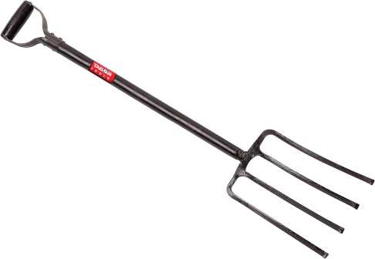

19. Name the tool shown above.

___________________________________________________________________

20. Mention one material used to make the tool shown above.

___________________________________________________________________

21. How is the tool shown above useful in a home?

___________________________________________________________________

___________________________________________________________________

**For questions 22 and 23, write a sentence using the given names.**

22. Walumbe ___________________________________________________________

23. Kaikuzi __________________________________________________________

**In each of the questions 24 to 26, write the given abbreviations in full.**

24. L.C _______________________________________________________________

25. Sch. ____________________________________________________________

26. TV ________________________________________________________________

**In questions 27 to 31, give one word for the given group of words.**

27. land between two close hills.

____________________________________________________________

28. Vehicle for carrying sick people.

________________________________________________________________

29. A man who makes chairs, tables, stools, cupboards.

_________________________________________________________________

30. Capital city of Uganda.

___________________________________________________________________

31. an instrument used to tell direction.

___________________________________________________________________

**In each of the questions 32 to 35, name the feature shown by the map symbol.**

32. _________________________________________

33. ________________________________________

34. _________________________________________

35. ________________________________________

**For each of questions 36 to 40, answer EITHER a Christian OR Islamic question but not both.**

36. **Either:** Who built the ark?

________________________________________________________

**Or:** Who built the Ka’aba?

________________________________________________________

37. **Either**: Why do Christians pray?

______________________________________________________

________________________________________________________

**Or** : Why do Moslems pray?

________________________________________________________

_______________________________________________________

38. **Either**: Where did Adam and Eva live?

________________________________________________________

_______________________________________________________

**Or** : Where did Adam and Hawa live?

________________________________________________________

_______________________________________________________

39. **Either:** How does a Christian show respect for God?

________________________________________________________

_______________________________________________________

**Or** : How does a Moslem show respect for God?

________________________________________________________

_______________________________________________________

40. **Either:** What is Lent?

________________________________________________________

_______________________________________________________

**Or** : What is Saum?

________________________________________________________

_______________________________________________________

**SECTION B**

41. **Read and answer** True **Or** Untrue **about the ethnic groups.**

(a) We get educational services from hospitals. _________________

(b) Father, mother and their children form a nuclear family. _______________

(c) A mobile telephone gives us information and music. _________________

(d) A valley is a raised piece of land. ________________

42. **From the list below, form a list of four modern means of communication.** horn smoke signal whistles ___________________

internet radio television __________________

drum telephone messengers __________________

__________________

43. (a) **Write the products we get from the following crops**.

(i) sun flower _________________

(ii) cotton _________________

(iii) sugarcane _________________

(b) What name is given to crops grown for eating?

______________________________________________________________

44. **Underline the odd man in the lists below.**

|  |  |  |  |
| --- | --- | --- | --- |
| **A** | **B** | **C** | **D** |
| Omugabe  President  Kyabazinga  Kabaka  Emorimor | ship  canoe  train  ferry | beans  coffee  cassava  potatoes | Bakisimba  Temenaibuga  Larakaraka  Baganda |

45. **Study the diagram below and answer the questions that follow.**

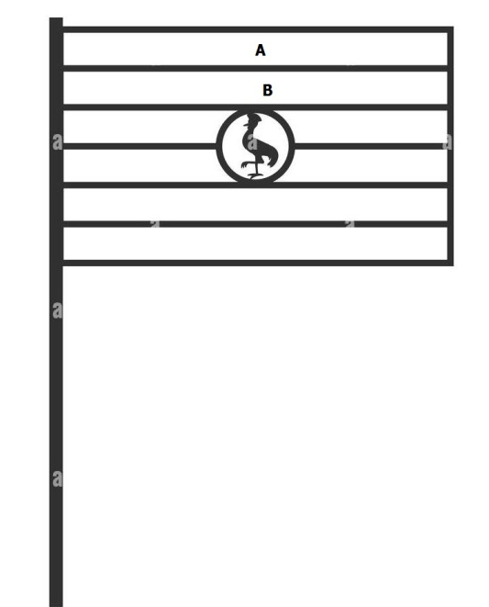

(a) What does the diagram above show?

____________________________________________________________

(b) Name the bird found in the diagram above.

__________________________________________________________

(c) Name the colours found in places **A** and **B**.

(i) **A** ___________________________________________________________

(ii) **B** ___________________________________________________________

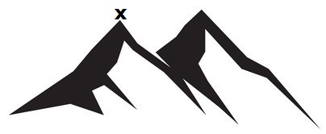46. **The diagram below shows a mountain. Study it and answer the questions that follow.**

(a) Name the point marked **X**.

_________________________________________________________________

(b) Give the highest mountain in Uganda.

__________________________________________________________________

(c) Which letter has been used to show the slope?

_______________________________________________________________

(d) Name any one hill found in Kampala.

_________________________________________________________________

47. **Read and fill the gaps to make the passage complete.**

(a) ______________________ is a group of people who have the same origin, culture and speak related languages.

(b) Ethnic groups in Uganda include the Bantu, Nilotics, Nilo-hamites and ___________________. The largest ethnic group is ____________________ and they have a common word “ntu” which means people.

48 **Match the animals to their homes.**

**A (Animal) B (Home)**

gorilla sty

rabbit stable

horse hutch

pig nest

kennel

49. **Write the place of work for these people.**

(i) Teacher: ____________________________________________________

(ii) Doctor: ____________________________________________________

(iii) Soldier: ____________________________________________________

(iv) Priest: ____________________________________________________

50. **Re-arrange these sentences to make a good story about the sun and its movement.**

* It then sets in the west in the evening.
* Then, we can see our shadows in the west.
* The sun rises from the East in the morning.
* At mid-day, the sun is directly above our heads.

___________________________________________________________________________________________________________________________________________________________________________________________________________________________________________________________________________

**For each of the questions 51 to 55, answer EITHER the Christian OR Islamic question but not both.**

51. **Either**:

(a) Who created the world?

______________________________________________________________

(b) What was created on the last day?

____________________________________________________________

(c) Give two ways you can care for plants.

(i) ____________________________________________________________

___________________________________________________________

(ii) ____________________________________________________________

___________________________________________________________

**Or:**

(a) Name the source of light created by Allah.

____________________________________________________________

(b) Apart from the source of light, draw and name three things that Allah created.

|  |  |  |
| --- | --- | --- |
|  |  |  |
|  |  |  |

52. **Either:**

Write down any four apostles of Jesus.

(i) ___________________________________________________________

(ii) ___________________________________________________________

(iii) ___________________________________________________________

(iv) ___________________________________________________________

**Or:**

Write down any four prophets of Allah.

1. ______________________________________________________________
2. ____________________________________________________________
3. ___________________________________________________________
4. ___________________________________________________________

53. **Either**:

(a) Who baptized Jesus?

____________________________________________________________

(b) Name the river where Jesus was baptized.

___________________________________________________________

(c) Name one symbol of Christianity.

_____________________________________________________________

(d) Write the first book in the Bible.

___________________________________________________________

**Or:**

Write **true** or **false**

1. Muhammad was the first prophet in Islam. ________________
2. Sulat alfatiha is the first sulat in the Qur’an. ________________
3. Moslems pray seven times a day. __________________
4. Moslems fast during the month of ramathan. ____________

54. **Either:**

(a)What happened to the apostles on Pentecost day?

_____________________________________________________________

____________________________________________________________

(b) Write any three gifts of the Holy Spirit.

1. ___________________________________________________________
2. ___________________________________________________________
3. ___________________________________________________________

**Or:**

Write any four things which a Moslem must not do.

1. ____________________________________________________________
2. ____________________________________________________________
3. ___________________________________________________________
4. ___________________________________________________________

55. **Either:**

(a) Why did Jesus die on the cross?

­­­­______________________________________________________________

____________________________________________________________ted.__________________________________________________

(b) Name the day when Jesus died on the cross.

___________________________________________________________

(c) How many days did Jesus take to resurrect?

___________________________________________________________

(d) Name the day when Jesus resurrected.

___________________________________________________________

**Or**:

(a) In which language was the Qur’an written?

______________________________________________________________

(b) Name any two places where you can find a Qur’an.

(i) ___________________________________________________________

(ii) ______________________________________________________________

(c) Write how you can care for the Qur’an.

_____________________________________________________________

_____________________________________________________________

***Good Luc***